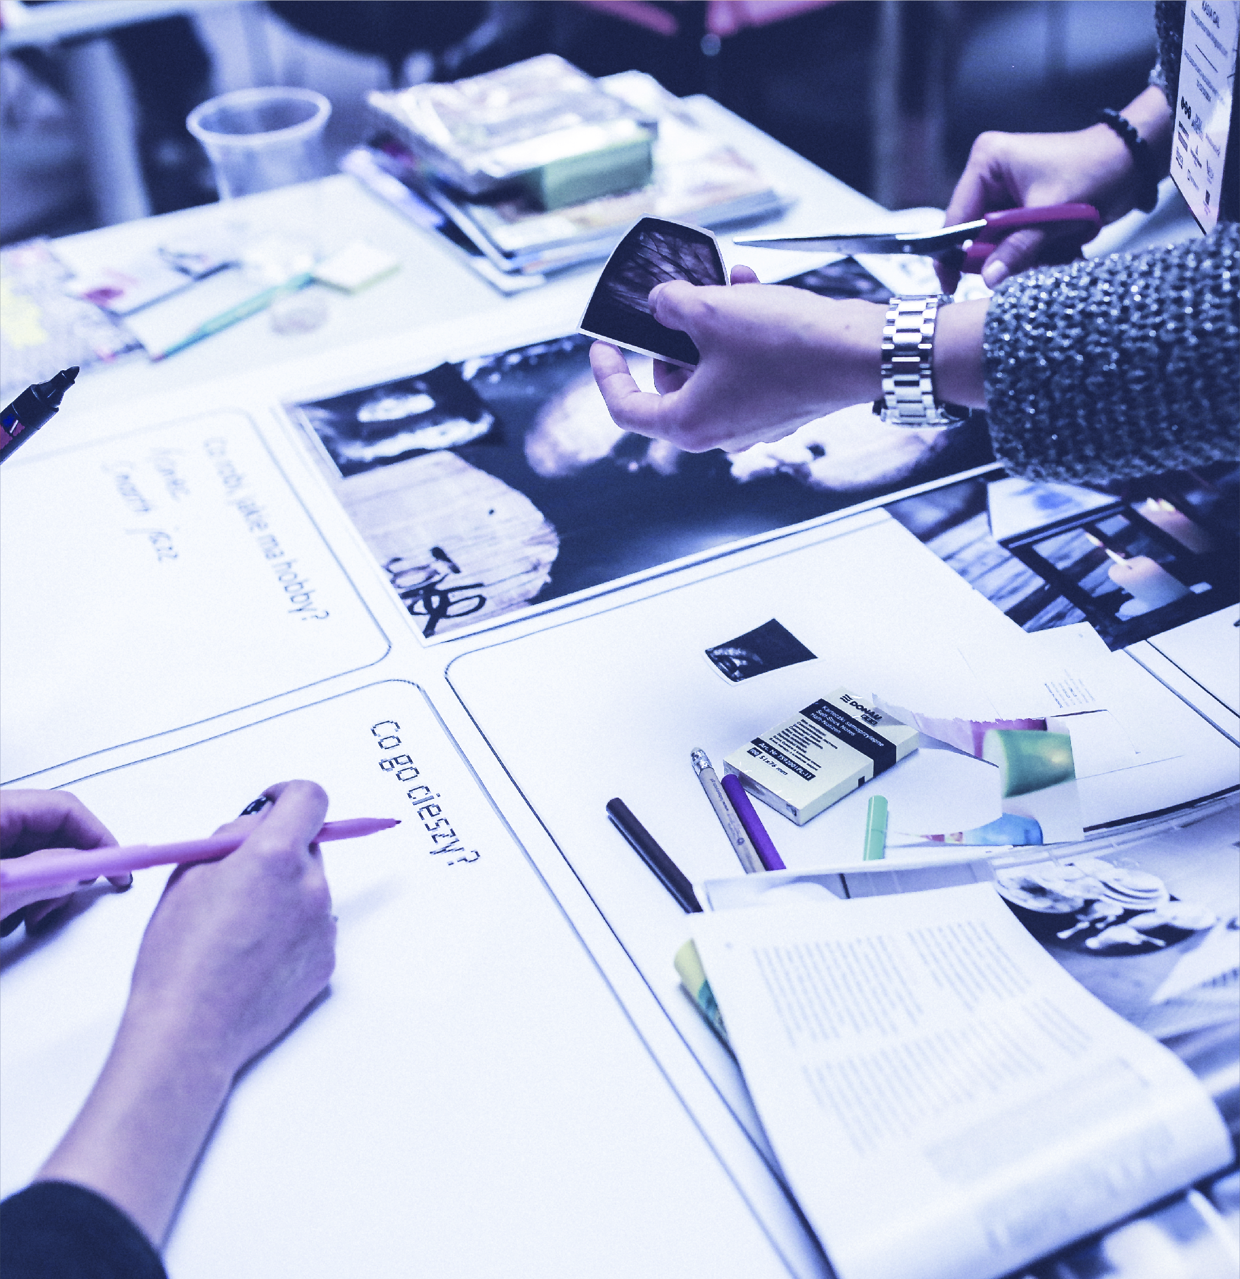
ANNUAL REPORT

2020
D.Y.K.B Inc
Email: ykborganization@gmail.com  Website: www.dykb.org | Tel: [+1-707-372-9573  Suisun Ca 94585 | 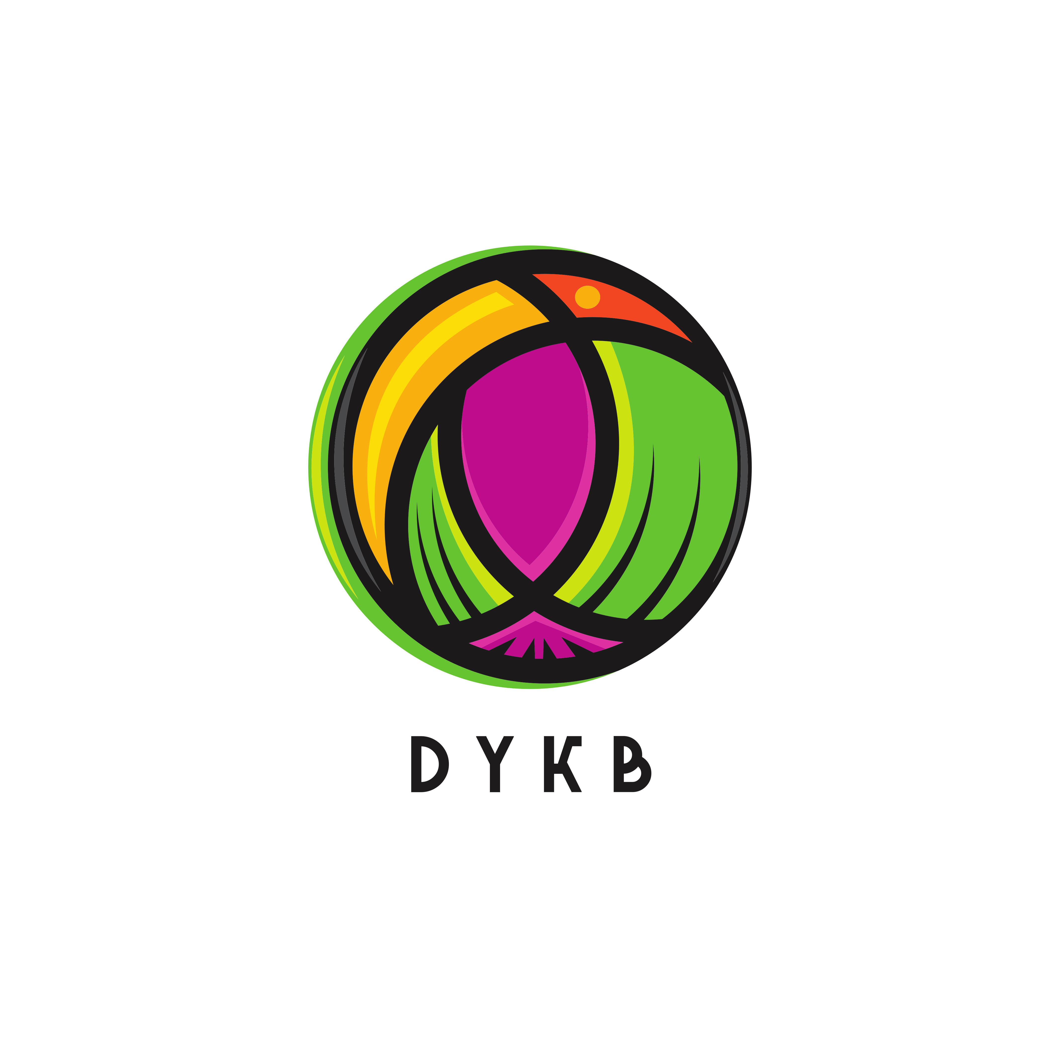
TABLE OF CONTENTS
Summary & Mission Statement
Strategic Highlights 3
Financial Highlights 3
Operating Highlights 3
Looking Ahead 4
FINANCIAL SUMMARY 5-8
FINANCIAL STATEMENTS 9
Statement of Financial Position 9
Statement of Comprehensive Income (Profits and Losses) 9
Statement of Changes in Equity 9
Statement of Cash Flows 9
NOTES TO FINANCIAL STATEMENTS 10
Accounts 10
Debt 10
Debt 10
Going Concern 10
Contingent Liabilities 10
Takeaways 10

Summary & Mission Statement

Mission Statement
Our mission is to develop the youth worldwide into leaders who can take their visions to the next level. Leaders that will recognize an issue and develop a sound strategy then create a solution that will drive the change that is needed. No matter the difficulty of the situation or location in which it is found.

Financial Highlights
Although our flagship program was shut down due to the Corvid 19 outbreak, i.e., The Youth Kickball League, we were still able to move into our year two and three programs and raise over $6,000 to support these programs. We have a full layout of our financial activities within this report to show you how we were able to hit these numbers and where the funds were applied to show the direction in which we will be heading for year two.

Operating Highlights
Our organization has grown from a few individuals to over 25 volunteers working on a total of 6 programs on the ground, not only in the U.S. but also worldwide. We are in four countries right now, including Ghana, Cameroon, The United States & Kenya. Within the next three years, we will be expanding into several more!
In as little as ten months, we have grown from our initial program (The Youth Kickball League) into four on the ground programs.
- An international partnership with Adamah Ver Zerah in Ghana, building sustainable living situations in Cape Coast Ghana.
- A research and development project in Cameroon, searching for medial herbs and plants to improve the lives of those less fortunate than ourselves.
- The third program is one that is near and dear to my heart, The Youth Debate Team.
- Our fourth program is a multilevel children’s program from learning how to eat healthy as well as an online reading program designed to prepare the participants to be the next generation of live broadcasters to speechwriters.
Our motto is “Together we are better”

Looking Ahead

Our current programs are;
1. The Youth Debate Team
2. The Kids Programs
3. Youth Drone Project,
4. Earthbag Seed Banks Program,
5. West Africa Wells and Sanitation Development Project,
6. Medical Herb R&D Project in Cameroon.

I will fully layout the design and goals set forth for each program/project within this report to bring every one of our potential sponsors and supporters up to speed on our progress and goals. The only thing we want to see is the programs grow from the development stage into a situation where they are effectively producing what is needed in the areas they are being held. Each program has been fully designed to focus on the regions where they are located, from our program administrators that we interview and train to our volunteers stationed worldwide. We take the time needed, seeing that some areas are more comfortable to operate than others.
Dennis Jay Steward Jr
C.E.O
11/2/2020

FINANCIAL SUMMARY
We run several different donations and fundraising campaigns from GoFundMe to Facebook fundraisers. The reason we used these services is simple; it allows us to continually track not only how much is coming in but also where it is coming from. For example, using Flyer and hand to hand promotion, we were able to raise $1450 in only 2 of campaigns. Those campaigns ranged from Jan 10th to Feb 2nd.
Donations are the lifeblood of any Non Profit, they also show the amount of support an organization is able to generate. We were able to amass $6,132.99 on 8 dontation drives including the EDIL Grant of $3,000. Those campaigns involved the topics of general information about the mission statement for the organization and the path we expected to take to achieve it.

We have also included a chart to show you the usage of these funds to display better what we were able to accomplish with limited resources and volunteers. As we begin to bring year two into focus, our organizational chart will show you the lessons we have learned. The changes we have put into play to assist our volunteers better and increase the ability to fundraise and support our programs.
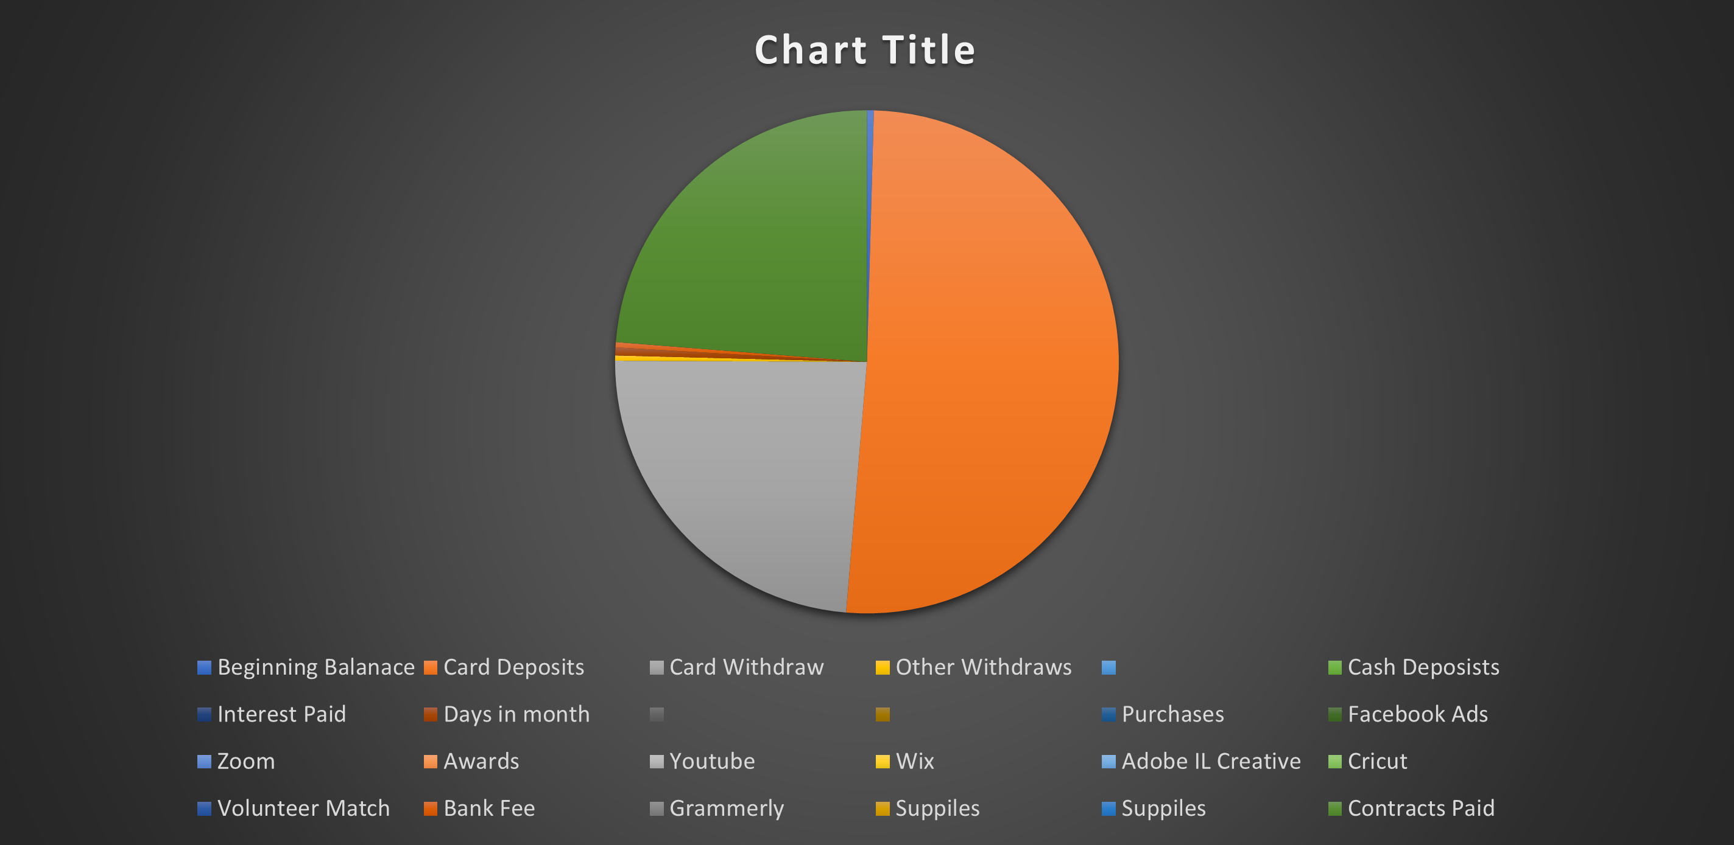

The above chart is for April 2020.

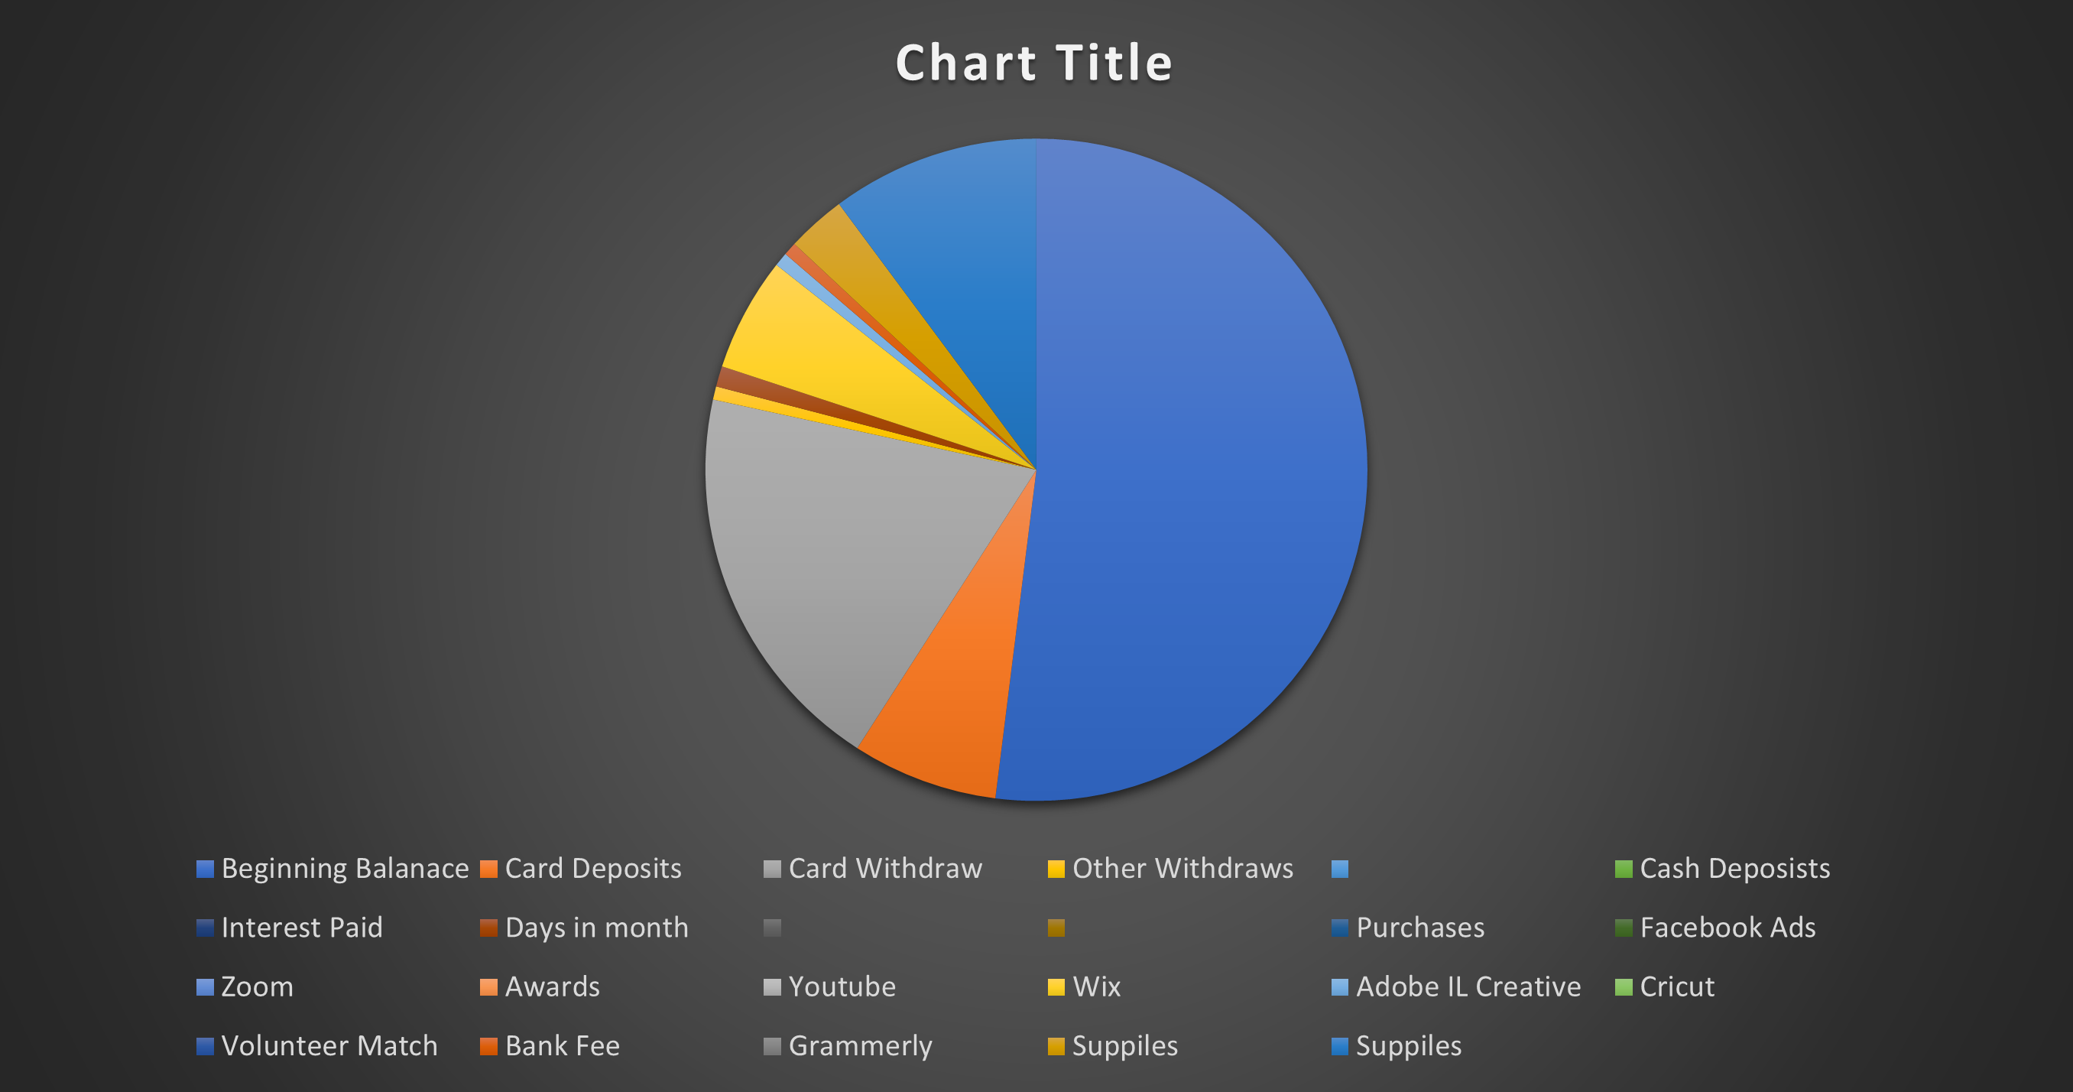

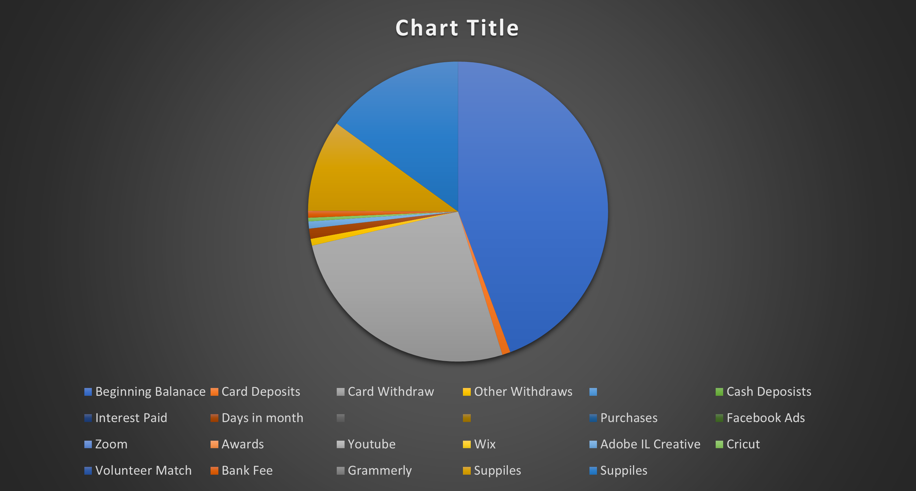

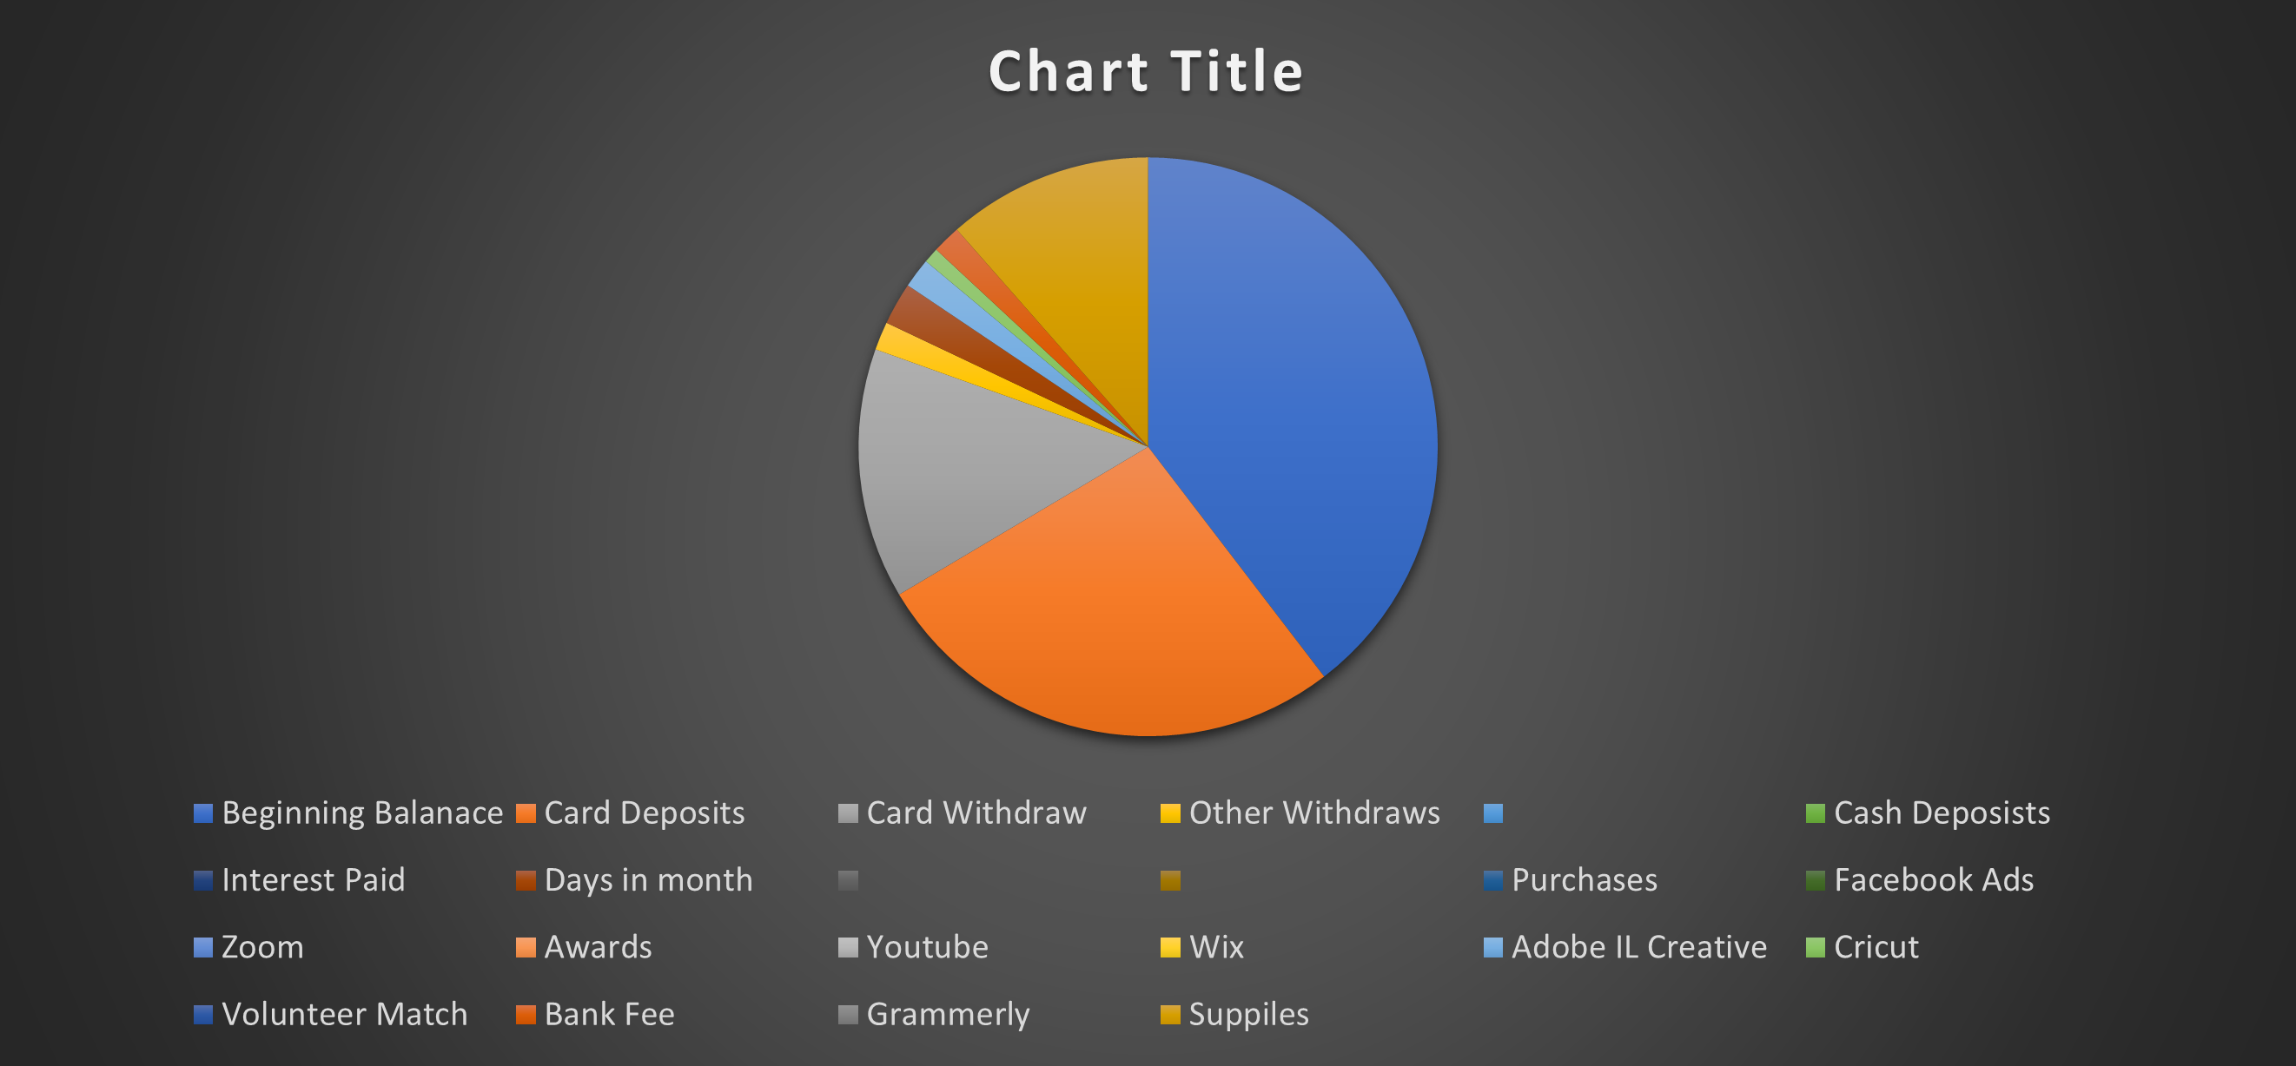

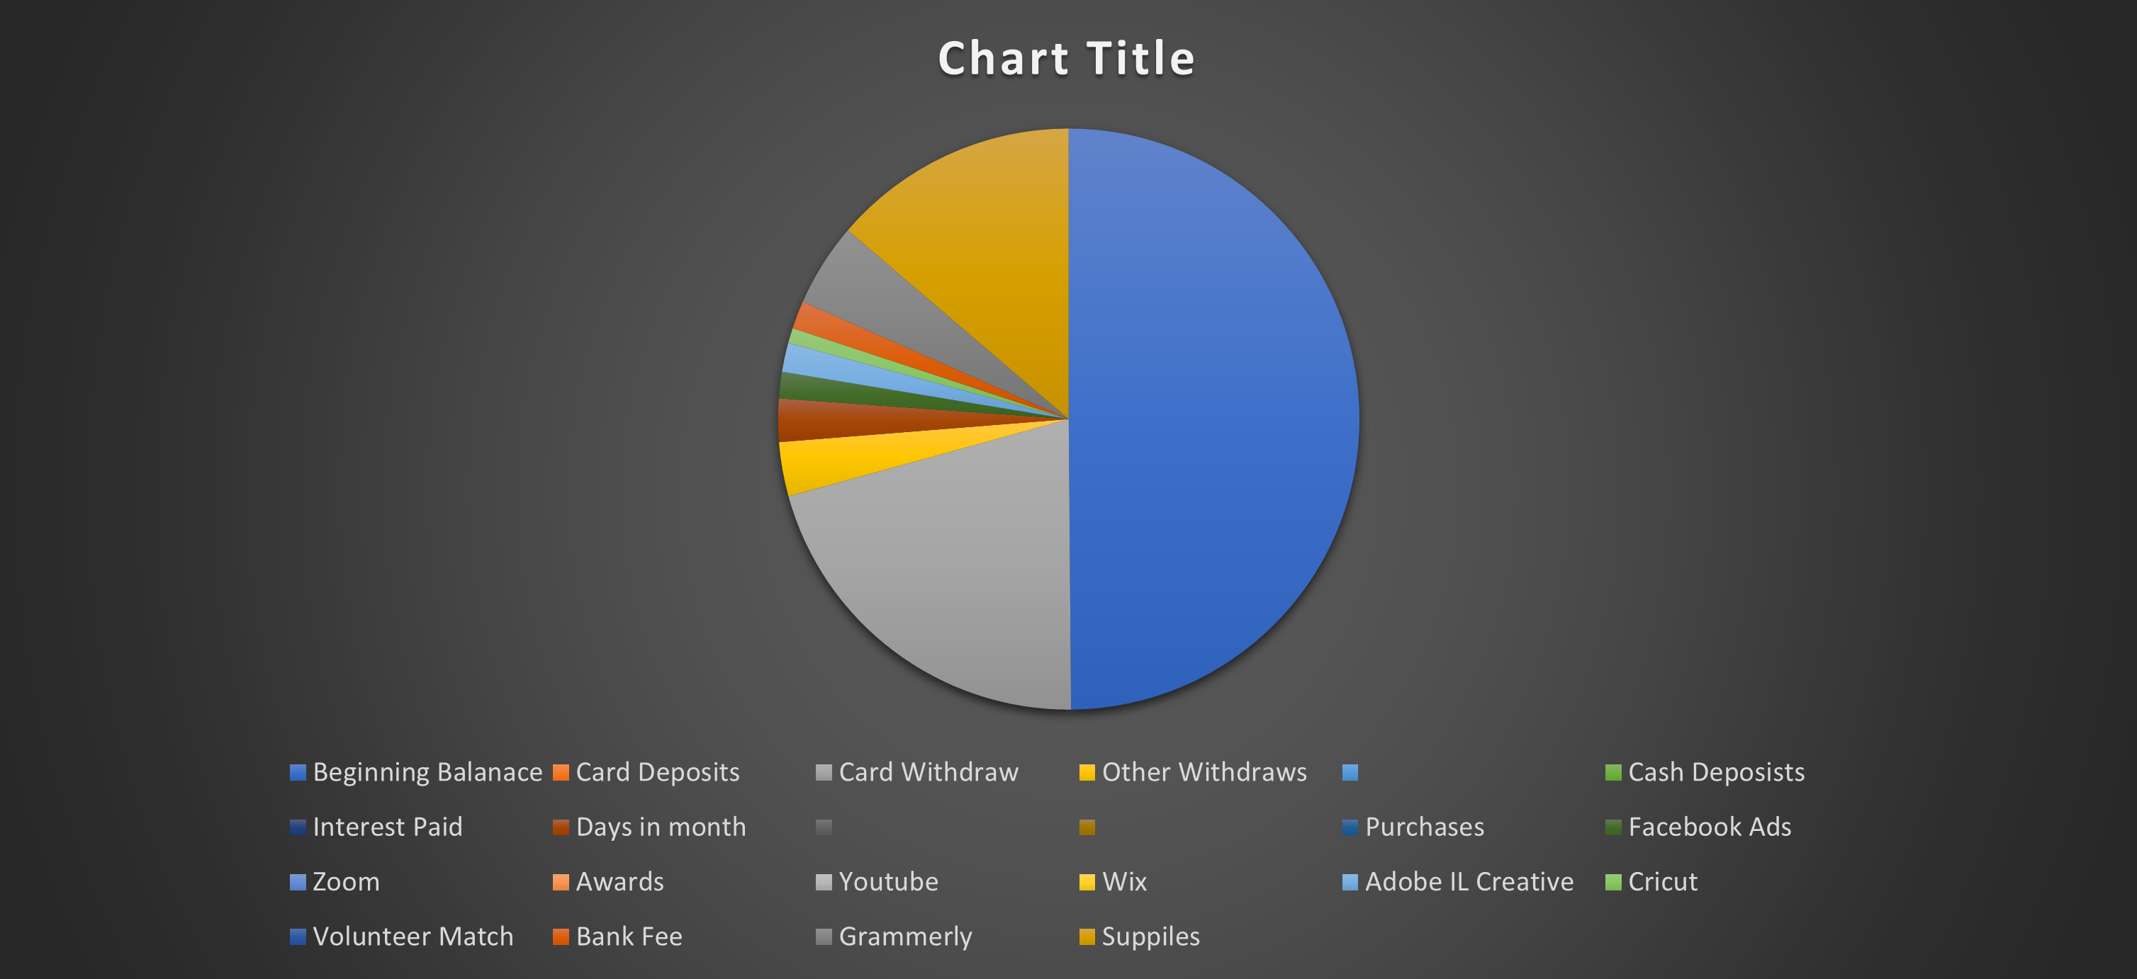

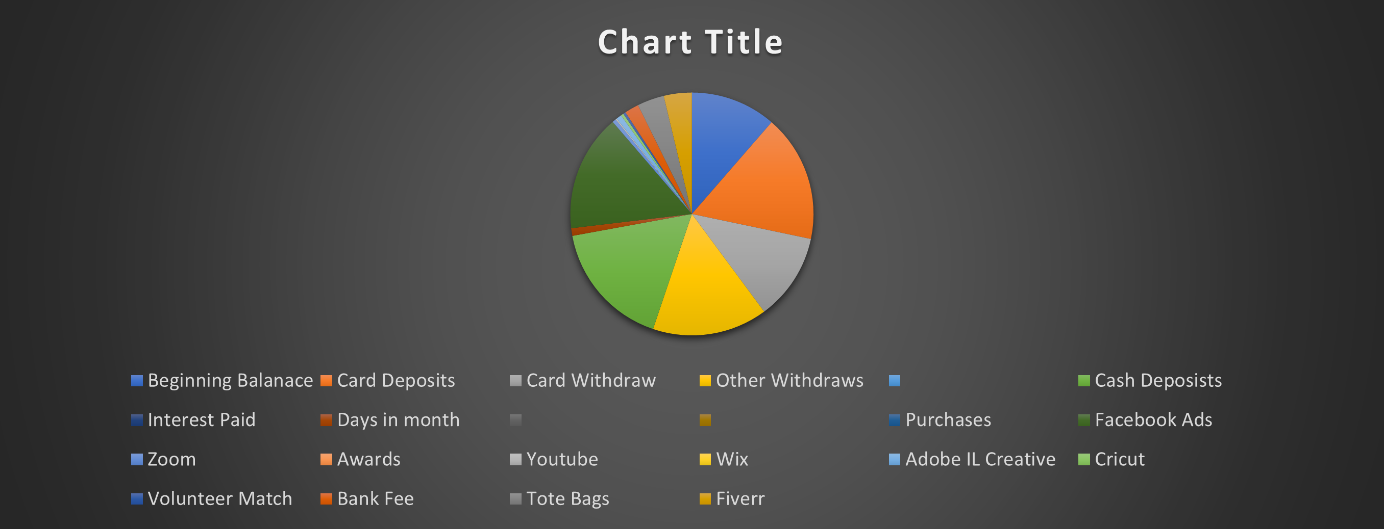

FINANCIAL STATEMENTS

Statement of Changes in Equity

DESCRIPTION | REVENUE | EXPENSES | EARNINGS
Donations | $6,132.99
Contracts  Cameroon Payment |  | $1400  $238.08
Supplies |  | $3585.27 | T- Shirt Press,Cricut Machine, Flyers, Ink, Printing Supplies
Promotion |  | $859.64 | Growth (Social Media)
Awards |  | $50 | Award to Volunteer

NOTES TO FINANCIAL STATEMENTS

Debt
$0
Our first year of operation has been very fruityfull. Having zero debt gives us a lot of room for growth over time. That and the understanding that we are structured to maintain zero debt should be very inviting for our future sponsors and donners.  Going Concern  Covid 19 has impacted the globe, with this understanding we are continuing to create interesting ways to work around this issue. | Takeaways  We feel our path forward is very clear. We will continue to grow the current programs and project that we started in 2020, while preparing for the next few years of expansion. Our growth in the online sphere has been our main focus and we will not stop we will continue to evole and stragiest as time moves forward.
“This is a journey we all have invested into.”

